REACT ASSIGNMENTS
Assignment 2:
Aim:
Create a react app for Student Management Portal named StudentApp and create a component named Home which will display the Message “Welcome to the Home page of Student Management Portal”. Create another component named About and display the Message “Welcome to the About page of the Student Management Portal”. Create a third component named Contact and display the Message “Welcome to the Contact page of the Student Management Portal”. Call all the three components.

1. Create the React Project
npx create-react-app StudentApp
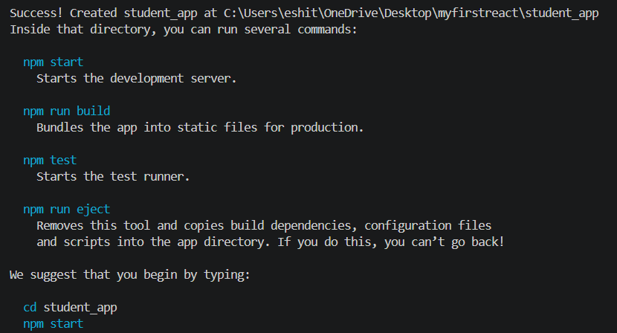
2. Go to the Project Folder
cd StudentApp
3. Run the Project
npm start
4. Home.js
function Home() {
return (
<h1>Welcome to the Home page of Student Management Portal</h1>
);
}

export default Home;
5. About.js
function About() {
return (
<h1>Welcome to the About page of the Student Management Portal</h1>
);
}

export default About;
6. Contact. Js
function Contact() {
return (
<h1>Welcome to the Contact page of the Student Management Portal</h1>
);
}

export default Contact;
7. App.js
import Home from "./Components/Home";
import About from "./Components/About";
import Contact from "./Components/Contact";

function App() {
return (
<div>
<Home />
<About />
<Contact />
</div>
);
}

export default App;
8. Output
